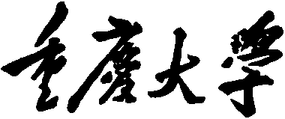
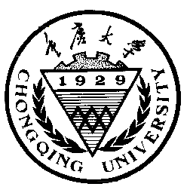

Personal Learning Portfolio

Course： English Academic Writing Teacher： Zhang Mei
Class： Major：
Name： Student Number：
Class Time： 2023.02-2023.07
Grade：

Self | Teaching Assistant | Teacher

Comments：

Teacher (Signature)
Contents

Week 1
- My learning
(本周课内外学了什么，建议以思维导图形式归纳和总结)
- Learning outcomes
（本周课内外学到了/学成了什么，列举哪些知识在未来的学习或者工作中如何使用。比如：当老师讲了如何做presentation之后，就可以列举出：1）When giving oral presentation，pay attention to the interaction with audience and PPT. 2）When giving oral presentation，think of the structure of my speech，such as Golden Circle，PREP.)
- My behavior and attitude (我课内外的表现与态度)
4．Improvement
第3和第4点可以从以下方面去考虑：
1）Out of Class
1.1 Autonomous learning（Online + Offline）
1.1.1 Online（MOOC or other platform online）
1.1.2 Offline（listening, speaking, reading, writing, translation）
1.2 Homework (on time; not leave your homework until deadline; serious attitude)
1.3 Cooperative learning（group discussion，making PPT，as a group leader，etc.）
2）In Class
2.1 Individual performance (Concentration, taking notes, questions and answers, comments).
2.3 Cooperation (Classroom discussion, Classroom presentation and performance)

Tips：
1）Innovation is encouraged in the form of writing.
2）Listen carefully and take notes.
3) Summarize every week!

每周用英语总结，包含以上四个方面(去掉老师的解释和说明)，17周必须提交，满分10分。

